**Speed Test Before VPN Connection**

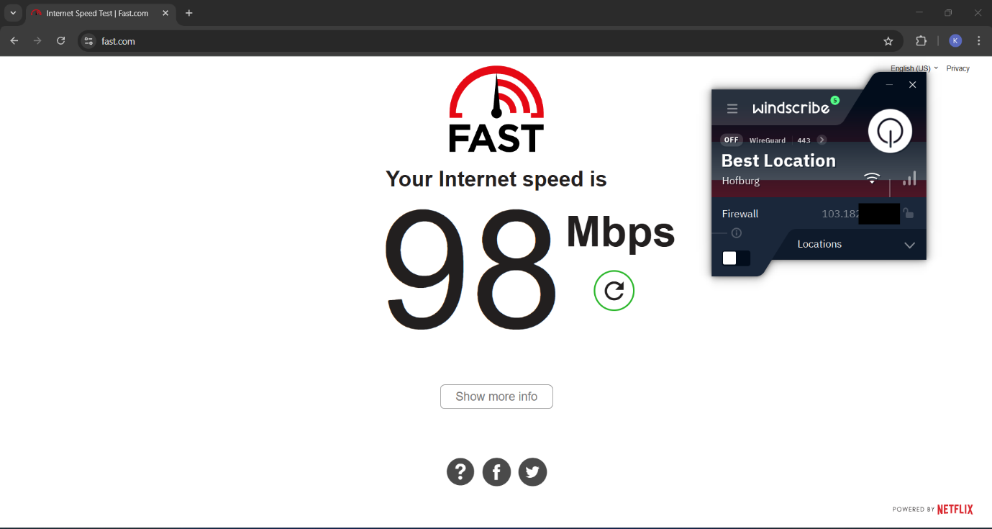

**Speed Test After VPN Connection**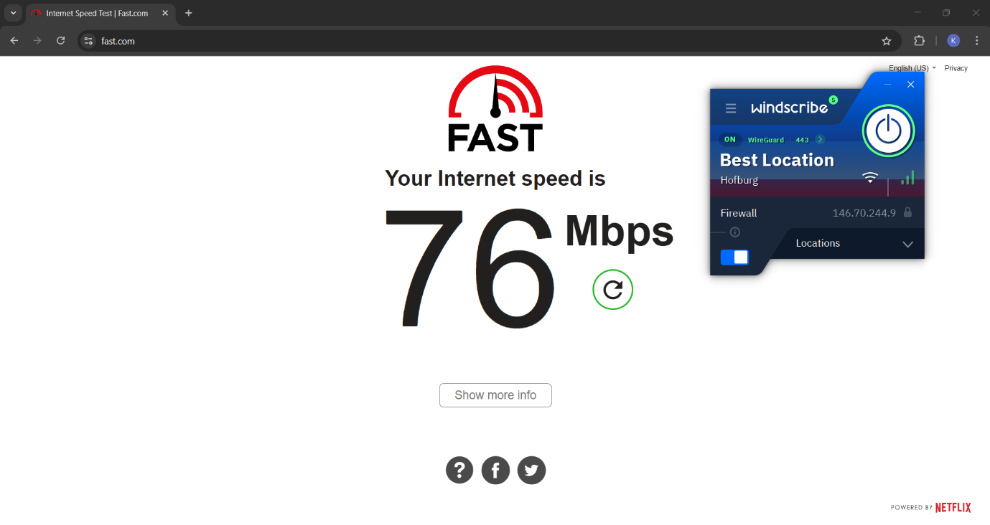

**IP Before VPN Connection**

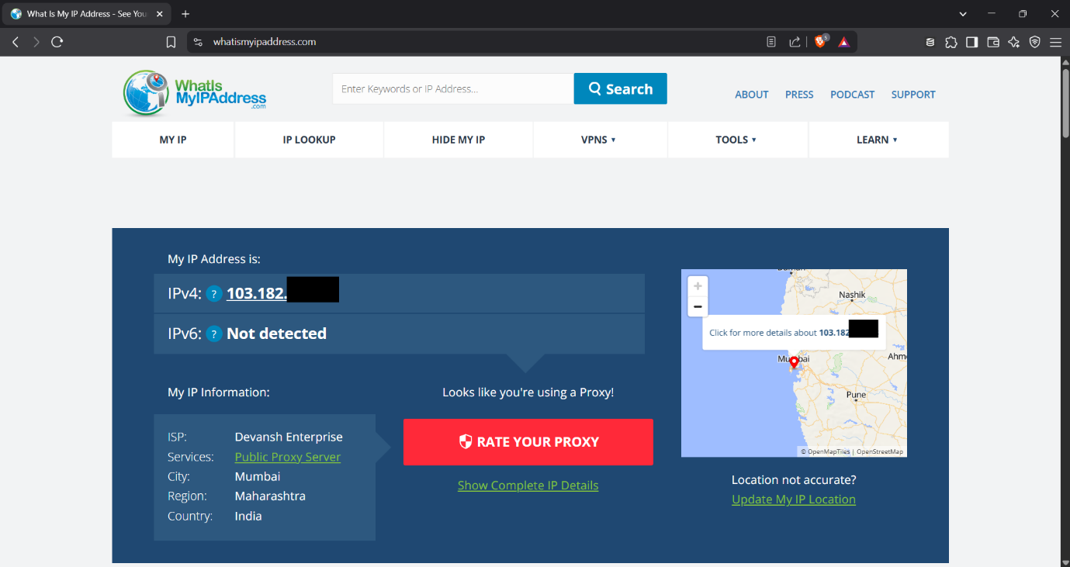

**IP After VPN Connection**

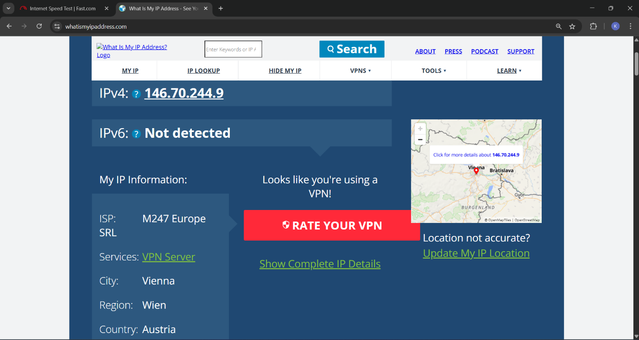

**Encryption Status After Connecting VPN**

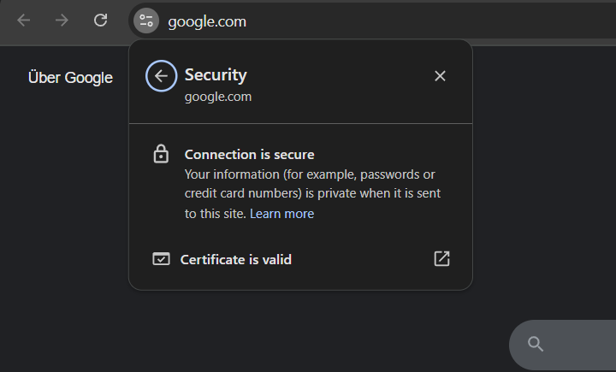

**VPN encryption and privacy features**

1. **Encryption Protocols:** VPNs use strong encryption protocols to secure your internet traffic. Common ones include:

* **OpenVPN** – Open-source, highly secure, and widely supported.
* **WireGuard** – Fast, modern, and lightweight protocol.
* **IKEv2/IPSec** – Stable and good for mobile devices.
* **L2TP/IPSec** – Older, slower, but still encrypted.

1. **Data Encryption:** VPNs encrypt data using AES-256, the same standard used by governments and banks. It ensures:

* Confidentiality of online activity.
* Protection from hackers, ISPs, and surveillance.

1. **IP Masking:** VPN hides your real IP address and assigns you a new one, protecting your identity and making it hard to track your location or online behaviour.
2. **DNS Leak Protection:** Prevents your DNS requests from leaking outside the VPN tunnel, ensuring no accidental exposure of visited websites.
3. **Kill Switch:** A safety feature that automatically disconnects your internet if the VPN connection drops, preventing data leaks.
4. **Split Tunnelling:** Lets you choose which apps or websites go through the VPN and which don’t—balancing privacy and speed.
5. **Obfuscation:** Some VPNs offer obfuscated servers to hide the fact you’re using a VPN, useful in restrictive environments (e.g., school networks, censored countries).

**Benefits of Using VPN:**

* **Hides Real IP Address:** Prevents websites and trackers from identifying actual location.
* **Encrypted Traffic:** Secures data even on public Wi-Fi.
* **Bypasses Geo-restrictions:** Allows access to region-locked content.
* **Built-in Firewall and Ad-blocker (R.O.B.E.R.T.):** Adds extra security and privacy.

**Limitations Observed:**

* **Speed Reduction:** Slightly slower internet speed when connected.
* **Data Cap:** 10 GB/month (for free users, with email verification).
* **Some Services blocks VPN Traffic.**